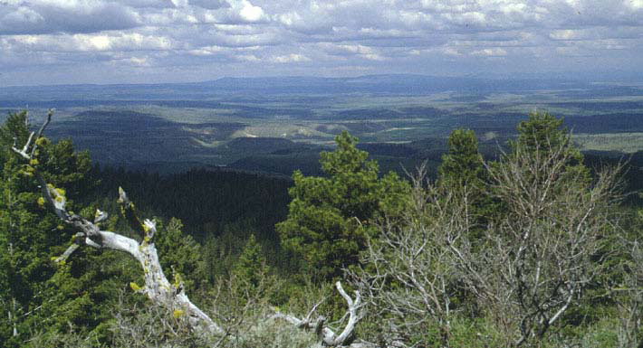

Ochoco National Forest

*“Caring for the Land and Serving People”*

OUTREACH NOTICE

**Botanist GS-0430-09/11**

**Paulina Ranger District**

**Prineville, OR**

**Ochoco National Forest**

**PERMANENT FULL-TIME**

**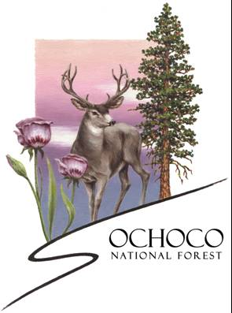*Please reply no later than June 4, 2021***

The Ochoco National Forest is conducting outreach to identify candidates for one GS-0430-9/11 position located on the Paulina Ranger District. This position reports to a District Ranger and oversees the districts botany and invasives program. This is a Permanent Full Time Position.

**ABOUT THE POSITION**

The position requires participation in the environmental analysis process as a resource specialist and core interdisciplinary team member. Strong interpersonal skills and the ability to work effectively in a team environment are essential. The successful applicant should demonstrate flexibility to build effective partnerships with internal and external collaborators. Priorities include supporting other district programs with needed botany expertise, coordinating revegetation/restoration project needs, surveying and monitoring sensitive plant species, invasive plant surveys and treatments, seed collection, and accurate data collection and organizational skills. The position helps lead seasonal field crews, youth crews, volunteer crews, and works closely with the county weed master.

**ABOUT THE FOREST**

The Ochoco National Forest is in central Oregon near the town of Prineville. The forest is dominated by dry forest, with some spectacular ponderosa pine stands, and some areas of moist mixed conifer forest. Water is complex with many springs across the forest as well as streams and critically important and unique wet and dry meadows. The South Fork of the John Day River borders the easternmost area of the forest. On the Paulina Ranger District unique scabland plateaus and timbered stringers characterize the landscape along with large meadows and tall ridges.

Ongoing projects and programs on the forest are varied and reflect the hard-working nature of the local population. Forest health restoration, fuels treatment, and grazing are the foundational elements of our forest program of work. An aggressive stream and riparian habitat restoration program is underway with many exciting opportunities on the horizon. Invasive plant management is a program on the rise with significant success in recent years. Recreation use is increasing, and opportunities abound to proactively manage experiences available to our forest visitors. Finally, the Ochoco National Forest is part of the Central Oregon Fire Management Service area and each fire season brings its own challenges and rewards.

**ABOUT THE PRINEVILLE AREA**

The City of Prineville, located 35 miles northeast of Bend and 20 miles east of Redmond, is a growing community in central Oregon within short distance of major recreation areas and larger metropolitan areas. The major highway through town is US Highway 26. The population is around 9,500 in the city with approximately 23,000 living in the surrounding area. There are numerous facilities in and adjacent to town, including: parks and outdoor recreational areas, a public library, full service medical and dental facilities, a shopping center, two golf courses, and numerous churches of various denominations.

**SCHOOLS**: Crook County School District has eight schools: one high school; one alternative high school and other alternative programs; one middle school; four elementary schools; and one charter school. Central Oregon Community College in Bend offers two-year programs as well as four-year degrees through Oregon State University and the University of Oregon. OSU Crook County Open Campus works to bring educational credit and non-credit classes from Oregon State University, Central Oregon Community College, OSU Cascades, and other institutions of higher education to Crook County.

**HEALTH CARE**: Prineville is home to Pioneer Memorial Hospital, which is a member of the regional St. Charles Healthcare organization. PMH is a fully accredited, critical-access hospital, licensed for 25 beds and capable of handling all routine and emergency medical matters. The hospital offers a comprehensive range of services, including laboratory and diagnostic imaging services. The hospital’s Emergency Department is open 24/7 and rated trauma Level IV. The hospital’s surgery unit and intensive care units are highly skilled and trained. In extreme cases, the hospital works closely with AirLink Critical Care Transport and St. Charles Hospital in Bend. There is also a family birthing center, extended care program, a home health care program and hospice care offered through the hospital. Prineville is also home to two clinics.

**HOUSING**: Rental apartments and houses are available in Prineville but can be difficult to find. The approximate range for the monthly cost of rentals is $1,000-$1,400 for a two-bedroom, one bath unit and around $1,200-$1,600 for a three-bedroom unit in either duplexes or apartments. The cost for a three-bedroom single-family house runs $1,500/mo. and up.

Prineville is a rapidly growing community with many new subdivisions. During 2020, the average selling price for a home in Prineville was $300,000, while for a single-family residence on rural acreage, the prices average $450,000 and up. The value of rural property is determined to a large extent on the availability of water.

**TRAVEL**: Prineville is 18 miles from Robert’s Field, the regional municipal airport in Redmond, OR, which offers daily commercial flights to a variety of locations, including: Portland International Airport (PDX); Seattle International Airport (SEA); San Francisco International Airport (SFO); Denver International Airport (DEN); Salt Lake International Airport (SLC); and Phoenix Sky Harbor International Airport (PHX).

Highway 26 passes through Prineville, while nearby Highway 97 offers a north-south corridor linking to Interstate 84 in the northern part of the state and to Klamath Falls in the south. Prineville is approximately a three-hour drive from Portland, Salem, Corvallis, and Eugene. Access is also easy to Highway 20 which provides access to Burns and eastern Oregon.

**WEATHER**: Crook County enjoys the dry climate of the high desert. Sunny days, low humidity and cool nights characterize the semi-arid climate in the high desert. The temperature can fluctuate more than 30 degrees in one day during the year. Like all of Oregon east of the Cascades, Prineville and Crook County’s weather is generally characterized by bright sunshine, hot days and cool nights in the summer, and sunny days and cool and cold temperatures in the winter. There is approximately 11″ of rainfall and between 9″ to 14″ of snowfall each year. Half of the precipitation falls between the months of October and February, and much of the precipitation is experienced as snow in the higher elevations.

More detailed information about Central Oregon may be obtained from the following websites:

<http://visitprineville.org>

<http://www.fs.usda.gov/centraloregon/>

<http://www.visitbend.com/>

**OUTREACH RESPONSE FORM**

**Ochoco National Forest, Paulina Ranger District**

**Botanist GS-430-09**

If you are interested in this position, please complete this form and email to Robbie Piehl at

[robbie.piehl@usda.gov](mailto:robbie.piehl@usda.gov) on or before June 4, 2021. Forms may also be mailed to Robbie Piehl at:

Ochoco National Forest, ATTN: Robbie Piehl 3160 NE Third Street, Prineville, OR 97754 or

FAX # 541-416-6695.

**Personal Information/Interest Form**

Name:       Date:    /    /

Address:       Phone: (   )     -

E-Mail:

Are you currently a Federal employee: Yes  No

If a Federal Employee, type of appointment you are currently under:

Career  Career-Conditional

Excepted-ANILCA  Excepted VRA

Other

Information on Current Position:

|  |  |
| --- | --- |
|  | POSITION TITLE |

|  |  |  |  |
| --- | --- | --- | --- |
|  | REGION |  | FOREST |

LOCATION:

|  |  |
| --- | --- |
|  | DISTRICT |

|  |  |  |  |
| --- | --- | --- | --- |
|  | SERIES |  | GRADE |

I am interested in the following opportunity:

Permanent FTE, Full-Time

120-Day Temporary Promotion Opportunity

Permanent Reassignment

HOW DID YOU FIND OUT ABOUT THIS OUTREACH NOTICE?

|  |
| --- |
|  |

Do you qualify for any of the following programs?

VRA – Veterans Recruitment Appointment Authority *(disabled veterans, veterans who served in a declared war, or in a campaign for which a campaign badge has been authorized, or awarded a Armed Forces Service Medal, and separated from active duty in the past 3 years)*

Military Spouse Hiring Authority *(Military spouses eligible under Non-competitive Appointment of Certain Military Spouses do not have a hiring preference; however, this appointing authority does provide for non-competitive entry into the competitive service. There are three categories that determine eligibility: those who are relocating with their service-member spouse as a result of permanent change of station (PCS) orders, spouses of service members who incurred a 100% disability because of the service member's active duty service, and spouses of service members killed while on active duty.)*

VEOA – Veterans Employment Opportunity Authority *(allows eligible veterans to apply for merit promotion vacancies otherwise not open to external candidates without career status)*

Prior AmeriCorps/VISTA *(persons are granted a one-year period to be non-competitively appointed to a normally competitive Federal position after leaving the Peace Corps or AmeriCorps VISTA with a certification of eligibility)*

30% Disabled Veterans Appointing Authority *(disabled veterans who were retired from active military service with a 30% or more disability rating; disabled veterans rated by the Veterans Affairs as having a compensable service-connected disability of 30% or more)*

Prior Peace Corps *(former Peace Corps volunteers who have satisfactorily completed 3 years of continuous service into career or career-conditional permanent positions)*

Schedule A Disabled Persons Hiring Authority *(persons with physical or mental disabilities certified by a licensed medical professional, Veterans Administration or a State Rehabilitation Agency as eligible)*

Reinstatement Rights *(agencies may reappoint people previously employed under a career or career-conditional appointment by reinstatement to a competitive service position)*

Pathways Student Hiring Authority *(Internship Program: current students in an accredited high school, college [including 4-year colleges/universities, community colleges, and junior colleges]; professional, technical, vocational, and trade school; advanced degree programs; or other qualifying educational institution pursuing a qualifying degree or certificate; Recent Grads Program: recent graduates who have completed, within the previous two years, a qualifying associates, bachelors, masters, professional, doctorate, vocational or technical degree or certificate from a qualifying educational institution)*

**Briefly describe why you will be a quality candidate for this position: (Optional)**

**Please remember to attach your resume and any other supporting documentation you would like us to consider in this process.**



**USDA Non-Discrimination Statement**

In accordance with Federal civil rights law and U.S. Department of Agriculture (USDA) civil rights regulations and policies, the USDA, its Agencies, offices, and employees, and institutions participating in or administering USDA programs are prohibited from discriminating based on race, color, national origin, religion, sex, gender identity (including gender expression), sexual orientation, disability, age, marital status, family/parental status, income derived from a public assistance program, political beliefs, or reprisal or retaliation for prior civil rights activity, in any program or activity conducted or funded by USDA (not all bases apply to all programs). Remedies and complaint filing deadlines vary by program or incident.

Persons with disabilities who require alternative means of communication for program information (e.g., Braille, large print, audiotape, American Sign Language, etc.) should contact the responsible Agency or USDA’s TARGET Center at (202) 720-2600 (voice and TTY) or contact USDA through the Federal Relay Service at (800) 877-8339. Additionally, program information may be made available in languages other than English.

To file a program discrimination complaint, complete the USDA Program Discrimination Complaint Form, AD-3027, found online at <http://www.ascr.usda.gov/complaint_filing_cust.html> and at any USDA office or write a letter addressed to USDA and provide in the letter all of the information requested in the form. To request a copy of the complaint form, call (866) 632-9992. Submit your completed form or letter to USDA by: (1) mail: U.S. Department of Agriculture, Office of the Assistant Secretary for Civil Rights, 1400 Independence Avenue, SW, Washington, D.C. 20250-9410; (2) fax: (202) 690-7442; or (3) email: [program.intake@usda.gov](mailto:program.intake@usda.gov).

USDA is an equal opportunity provider, employer, and lender.