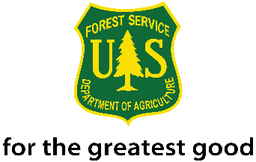
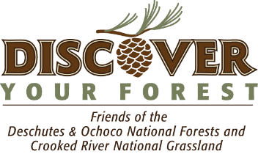
2016 Generation Green
21st Century Conservation Service Corps Internship
Ochoco National Forest Service

The Ochoco National Forest is seeking an intern to work in the Invasive Plant Program as an Invasive Plant Technician-Wilderness Liaison. The focus for this position is invasive plant management within areas with special management designations, such as Wilderness Areas and Research Natural Areas (RNA). The intern will help develop and deliver an integrated approach to the prevention, inventory, and control of invasive plants within three Wilderness areas and one RNA on the Ochoco National Forest using methods appropriate for Wilderness and other special designation settings. The intern will work closely with Invasive Plant and Recreation staff and will serve as an invasive plant liaison on the recreation crew. The intern will help educate staff internally and members of the public about invasive plants, methods of prevention, and management strategies. Housing may be available.

This internship is a 21st Century Conservation Service Corps (21CSC) Internship. Age requirement: 16-30 years and veterans up to 35 years of age. Internship duration: 640 hours and then intern will receive 2-Year non-competitive status hiring authority.
Stipend: $250 per 40 hours.

Skills the intern will have:
- Current driver’s license with good driving record.
- Willingness to obtain government driver’s license and drive government vehicles including 4 X 4 trucks in all types of weather.
- Interest in natural resource management.
- Excellent communication skills and willingness to learn about invasive plant, Wilderness management, and Research Natural Area management.
- Exceptional work ethic, enthusiasm, and high degree of flexibility.
- Ability to walk several miles a day for day trips into Wilderness areas, and to control weeds manually (weed pulling or use of hand tools).
- Willingness to assist with herbicide treatment applications under the supervision of licensed staff, including the use of a backpack sprayer (18+ only).

Skills the intern will develop:
- Better understand Forest Service career opportunities and pathways in Invasive Species Management, Botany, Recreation, and Wilderness Management.
- Learn how to identify, map, and treat invasive plant populations. Learn how to use maps or electronic devices to navigate and collect natural resource information.
- Gain knowledge of the 1964 Wilderness Act, Wilderness Ethics, Leave No Trace practices, and the U.S. Forest Service.
- Obtain a government license to drive a government vehicle. Complete online training and pass an exam.
- Confidence interacting with the public and Forest Service colleagues.
- Protocols and use of a government radio.
- Learn how to compete appropriate documentation reports.

To apply or learn more about this opportunity, please contact Stacey Cochran, Discover Your Forest Volunteer and Event Coordinator at 541-383-5530 or send a resume and cover letter to Stacey.cochran@discovernw.org.

21st Century Conservation Service Corps is an opportunity for an individual(s) between the ages of 16 and 30 years old (inclusive), and veterans up to 35, engaged as a crew member or intern through an organization that operates in partnership with the Forest Service, each participant will be paid a stipend of $250 per 40 hours served and has the option to gain credit as an intern or other definition through their academic institution. Working toward 640 hours of conservation or related service, of which at least 120 hours take place on an appropriate Forest Service project. Upon completion of the program, candidates have a 2-year window of eligibility for non-competitive hiring status.

Noncompetitive hiring status means the ability to apply and be considered for vacancies within the Forest Service without competitive examination or competing with career or career-conditional employees under internal merit staffing procedures for any position which eligible. Candidates applying under this authority are considered with other non-competitive candidates.

