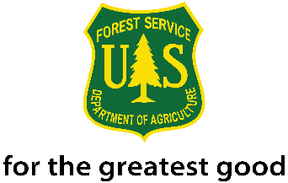
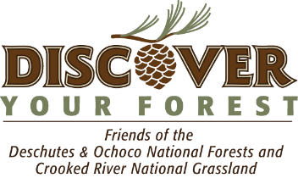
2018 Generation Green
21st Century Conservation Service Corps Internship
Deschutes National Forest Service

The Deschutes National Forest is seeking four interns to work in the Wilderness Program as educators both at Wilderness trailheads and in Wilderness areas. The interns will work in high use areas and interact with the public to inform them of trail conditions, Wilderness regulations, Leave No Trace practices, Wilderness Stewardship, and provide information on local topics. Housing may be available.

This internship is a 21st Century Conservation Service Corps (21CSC) Internship. Age requirement: 16-30 years and veterans up to 35 years of age. Internship duration: 640 hours and then intern will receive 2-Year non-competitive status hiring authority. There is an opportunity for Intern to receive an Americorps Education Grant after completing 450 of the 640 internship hours.

Stipend: $250 per 40 hours. $4,000 total stipend.

Application Window Closes: Fri, Feb 23rd
Interviews: March 5th – March 9th
Selections: Made by March 12th
Training will be held: TBD
Start Date: June 4th

Skills the intern will have:
- Current driver’s license with good driving record.
- Willingness to obtain government driver’s license and drive government vehicles including 4 X 4 trucks in all types of weather and at night.
- Excellent communication skills and ability to easily talk to a large numbers of people every day.
- Exceptional work ethic, enthusiasm, and high degree of flexibility.
- Commitment to work 4-ten hour days, with weekend work required.
- Ability to walk several miles a day for day trips into Wilderness areas.

Skills the intern will develop:
• Gain knowledge of the 1964 Wilderness Act, Wilderness Ethics, Leave No Trace practices, and the U.S. Forest Service.
• Obtain a government license to drive a government vehicle.
• Confidence interacting with the public and answering questionsas a representative of the US Forest Service
• Learn how to compete appropriate documentation reports.
• Map reading skills and ability to navigate with a compass.
• Interpret the area to both highlight natural features as well as educate about LNT ethics and wilderness stewardship.
• Learn to “read your audience” - to answer questions in a method that they will understand

To apply or learn more about this opportunity, please contact Stacey Cochran, Discover Your Forest Community Engagement Director at 541-383-5530 or send a resume and cover letter to Stacey.cochran@discovernw.org.

21st Century Conservation Service Corps is an opportunity for an individual(s) between the ages of 16 and 30 years old (inclusive), and veterans up to 35, engaged as a crew member or intern through an organization that operates in partnership with the Forest Service, each participant will be paid a stipend of $250 per 40 hours served and has the option to gain credit as an intern or other definition through their academic institution. Working toward 640 hours of conservation or related service, of which at least 120 hours take place on an appropriate Forest Service project. Upon completion of the program, candidates have a 2-Year window of eligibility for non-competitive hiring status.

Noncompetitive hiring status means the ability to apply and be considered for vacancies within the Forest Service without competitive examination or competing with career or career-conditional employees under internal merit staffing procedures for any position which eligible. Candidates applying under this authority are considered with other non-competitive candidates.

