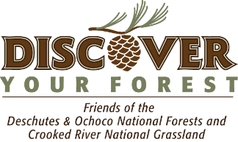
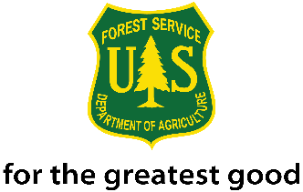
Community Ambassador Program Coordination Assistance
2016 Generation Green Internship
Ochoco National Forest Service

The Ochoco National Forest is seeking an intern to work in the newly-established Community Ambassador Program, which focuses on making visitor contacts to increase understanding of natural resource management. The intern will be based out of Prineville and will assist with the planning, preparation and patrols for the Community Ambassador program for the Ochoco National Forest and the Crooked River National Grassland.
Internship Stipend: $250 for every 40 hours served.

Tasks include:
Patrolling the forest to hand out motorized travel maps
Stopping to speak with visitors about fire safety and Leave No Trace principles
Spending time at highly visible restoration projects to speak with visitors about project goals
Assisting with conservation education at local events and schools
Helping to disseminate information on fire restrictions or wildfires
Helping to coordinate volunteer work days
Preparing informational hand outs and fact sheets
Stopping to discuss visitor concerns with the public and reporting back to forest staff
Photographing items of interest or concern as observed in the field
Assisting with routine campground maintenance
Helping to install road signage

Skills required:
A current driver’s license
A passion for people and willingness to engage the public
Interest in learning about public lands issues and best practices
Basic abilities to navigate with a map and use radio communication
Basic ability to use a computer and the internet to gather information

Skills the intern would acquire:
Experience working for a land management agency
Familiarization with federal land management policies and challenges
Interpersonal and public communications

The selected individual may also assist with Recreation and Special Uses program duties including campground and trail maintenance and assisting with permit applications, correspondence and filing.

21st Century Conservation Service Corps is an opportunity for an individual(s) between the ages of 16 and 30 years old (inclusive), and veterans up to 35, engaged as a crew member or intern through an organization that operates in partnership with the Forest Service, each participant will be paid a stipend of $250 per 40 hours served and has the option to gain credit as an intern or other definition through their academic institution. Working toward 640 hours of conservation or related service, of which at least 120 hours take place on an appropriate Forest Service project. Upon completion of the program, candidates have a 2-Year window of eligibility for non-competitive hiring status.

Noncompetitive hiring status means the ability to apply and be considered for vacancies within the Forest Service without competitive examination or competing with career or career-conditional employees under internal merit staffing procedures for any position which eligible. Candidates applying under this authority are considered with other non-competitive candidates.

To apply or learn more about this opportunity, please contact Stacey Cochran, Discover Your Forest Volunteer and Event Coordinator at 541-383-5530 or send a resume and cover letter to Stacey.cochran@discovernw.org.

